11.2: The calculation of Exercise 11.1 becomes
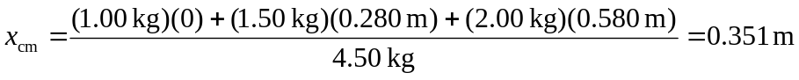
This result is smaller than the one obtained in Exercise 11.1.

